**Kawartha Lake Stewards Association**

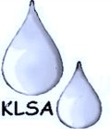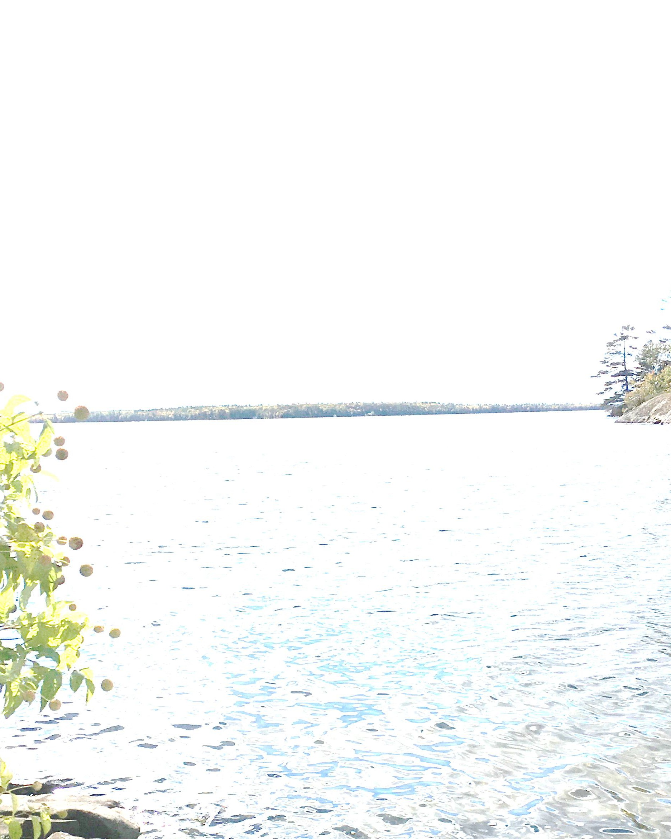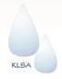

**2018 Annual Spring Meeting**

**When:** Saturday May 5 from 10:00 – 12:00

**Where:** The Bobcaygeon Community Centre (51 Mansfield Drive)

*Please join us in a morning of scientific inquiry, presentations, and conversation*

*regarding the health of our important Kawartha Lakes. Hear about KLSA activities,*

*including an update on the E. coli trends and lake monitoring programs.*

**Youth and the Environment: Teaching and Learning: an ecosystem approach**

# With guest presentations by:

## Mr. Jacob Rodenburg (“Pathways to Stewardship & Kinship”)

Jacob is Executive Director, Camp Kawartha & the Camp Kawartha Outdoor Education Centre/Environment Centre. These facilities teach children and future teachers about sustainable living practices, alternative energy and conservation.  The [**Pathway to Stewardship**](https://campkawartha.ca/pdf/Pathway-to-Stewardship.pdf) approach provides children with the experiences they need to become future stewards.

*And*

## Bretton Clark and Briagh Hoskins-Hasbury (“ Environmental Education: Toddlers to Paddlers”)

Bretton and BriaghCo-founders of the Land- Canadian Adventures and are passionate about sharing Canadian backcountry wisdom and experience with visitors and locals alike. Their programs have provided outdoor learning and wilderness experiences for youth in both Canada and internationally.

**ALL ARE WELCOME ---- ADMISSION FREE**

**We welcome donations to support the work of the KLSA.**

**For more information see our website:** [**https://klsa.wordpress.com/**](https://klsa.wordpress.com/)

**or send us an e-mail at** [**kawarthalakestewards@yahoo.ca**](mailto:kawarthalakestewards@yahoo.ca)