2021 Lake Partner Program Results
Total Phosphorus, Secchi Depth and Calcium
Mike Dolbey, KLSA Director
C. Lee, KLSA Director

Why measure phosphorus levels in lake water?
Phosphorus is regarded as the chemical that is most responsible for increased plant and algal growth in freshwater lakes. Sources of phosphorus include shoreline erosion, fertilizers, wildlife, septic systems, sewage treatment plants and pets. Limited fertilizer use and a well-vegetated shoreline are good ways to limit your phosphorus input and keep our lakes clear. The Ontario Ministry of the Environment, Conservation and Parks issued the following guidelines for total phosphorus in our lakes:
• To avoid nuisance concentrations of algae in lakes, average total phosphorus concentrations for the ice-free period should not exceed 20 µg/L (equal to 20 parts per billion, (ppb)).
• A high level of protection against aesthetic deterioration will be provided by a total phosphorus concentration for the ice-free period of 10 µg/L or less.

2021 Phosphorus Testing Results
Thank you to all our volunteer testers who were able to collect samples and measurements in 2021. The continuity of these long-term data sets to establish trends in this era of climate change is of great value. If you are unable to continue testing, please let any director in KLSA know, so we can help you find a replacement. The program is free, and kits are mailed to you along with instructions. We have fairly complete coverage of the Kawartha Lakes, but many volunteers would welcome an assistant.

After the COVID-19 pandemic decimated most of the 2020 Lake Partner Program (LPP) sampling season, we are pleased to report that testing in 2021 returned to normal. In 2021, total phosphorus (TP) and Secchi depths were measured at 47 sites on 17 lakes in our area. Four to six samples were collected at most sites between May and October. Samples were analyzed by the Ministry of the Environment, Conservation and Parks’ Lake Partner Program. The TP data for hundreds of LPP sites on Ontario lakes can be found on the Federation of Ontario Cottagers’ Associations (FOCA) website or in the Province of Ontario’s Data Catalogue. Here we provide an analysis of the 2021 results for lakes in KLSA’s area. The complete tables of TP measurements, Secchi depths and Calcium levels are presented in Appendix F.

Lake to Lake Phosphorus Results
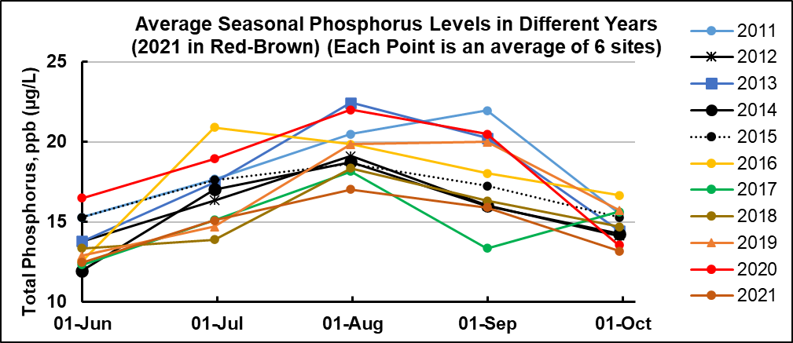
In most of our Kawartha lakes TP varies seasonally starting low in the spring, increasing to a maximum in August/September before declining in the fall. The average seasonal variation, based on the same six sites across the system, for each of the past ten years is shown in the graph below. In 2021, while the variation remained typical, the maximum was the lowest in the past ten years. Over the years KLSA has attempted to determine what causes differences in TP levels from one year to the next with limited success. However, rainfall and its effect on flow in the Trent-Severn Waterway (TSW) appears to be a significant factor. Localized summer thunderstorms have relatively little effect but a day-long steady rain throughout the watershed often takes a week of high flow to restore TSW water levels. The high flows both flush the system of high phosphorus water and increase mixing of the surface and bottom water which reduces internal loading, i.e. the release of phosphorus from the sediments during anoxic conditions.
The winter of 2021 was characterized by moderate temperatures and little snow that resulted in an early and modest spring flood. May and June were quite dry followed by widespread rains in July that resulted in higher flow in the Trent-Severn Waterway throughout the month. August was dry with low flow followed by a wet September that again led to increased water flow that continued until late October as the Trent-Severn Waterway drew down the feeder lakes to prepare for next year’s freshet. It appears that the widespread rains of July and September resulted in the lower than usual TP levels this year.
In general, the results for individual lakes follow a similar pattern to results from previous years. For consistency with past years, we present the results in graphical form grouped by the type of lake, Low Phosphorus Lakes, Upstream Lakes, Midstream Lakes and Downstream Lakes.

Low Phosphorus Lakes
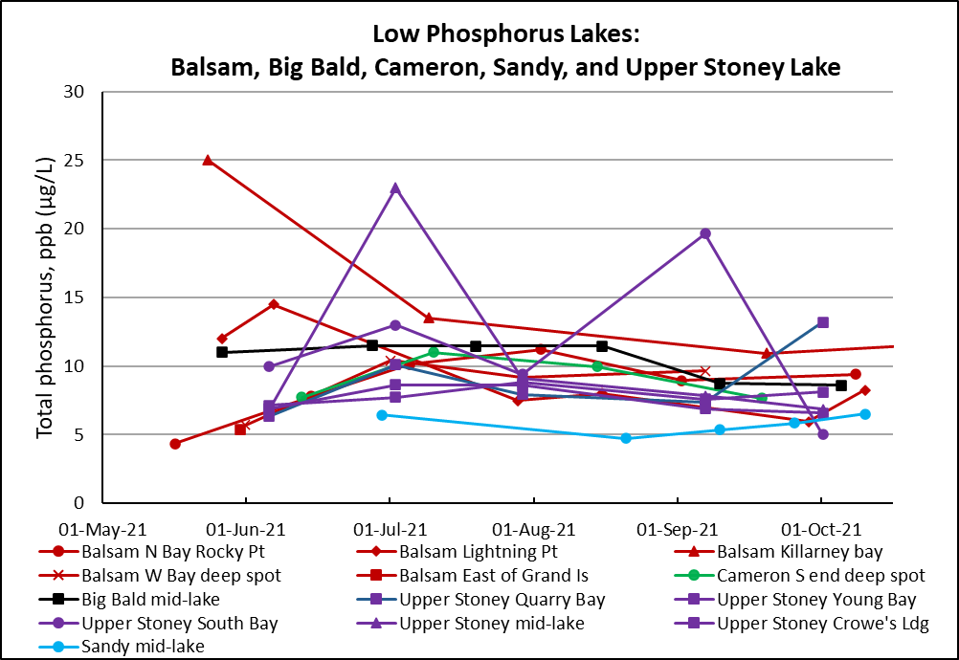
The low phosphorus lakes traditionally have low, stable TP levels, being fed with low phosphorus water from the north. The early high readings in 2021 at Balsam Lake’s South Bay/Killarney Bay site and Upper Stoney mid-lake are unusual and unexplained. The majority of readings fall between 7 and 12 µg/L, a bit lower than the 7 to 15 µg/L measured in 2019.

Upstream Lakes
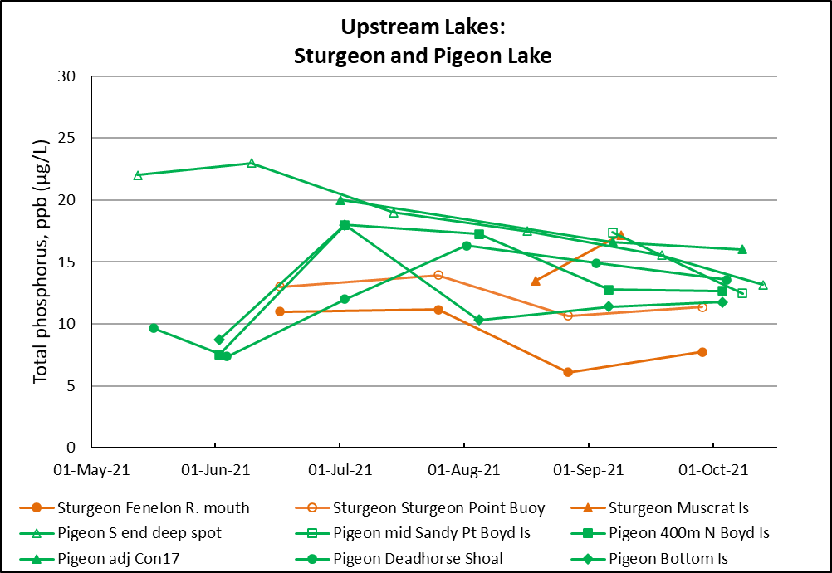
Sturgeon Lake receives low phosphorus water from the Fenelon River to the north and high phosphorus water from the Scugog River to the south. This is reflected in the low results of the Fenelon River mouth site and higher readings at the Sturgeon Point site where the two flows mix. Unfortunately, we no longer have a test site in the high phosphorus south (Scugog) arm of Sturgeon Lake. Pigeon Lake receives water from Sturgeon Lake moderated by lesser inflows from the Bald Lakes and Nogies Creek to the north and the Pigeon River to the south. The high May and June readings at the Pigeon Lake south end deep spot are similar to 2019 and earlier results but we have little long-term data for this site. It is an important site because it monitors TP in inflow from the agricultural south of the watershed. Otherwise, the readings from Pigeon Lake follow the normal pattern but are generally lower in mid-year than in 2019.

Midstream Lakes
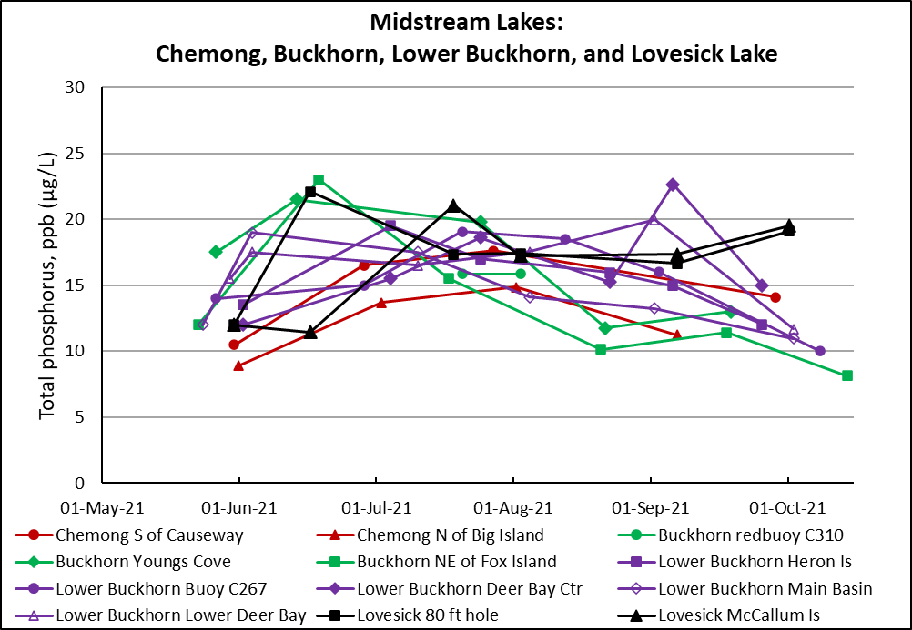
The midstream lakes usually have similar TP levels to the upstream lakes as was seen in 2021, including the generally lower mid-year levels compared to 2019. Two sites in the west end of Buckhorn Lake, sampled by different testers at about the same time in mid August, got similar low TP results for this time of year. TSW flow had been low for about a month by this time so flushing and mixing do not appear to provide an explanation.

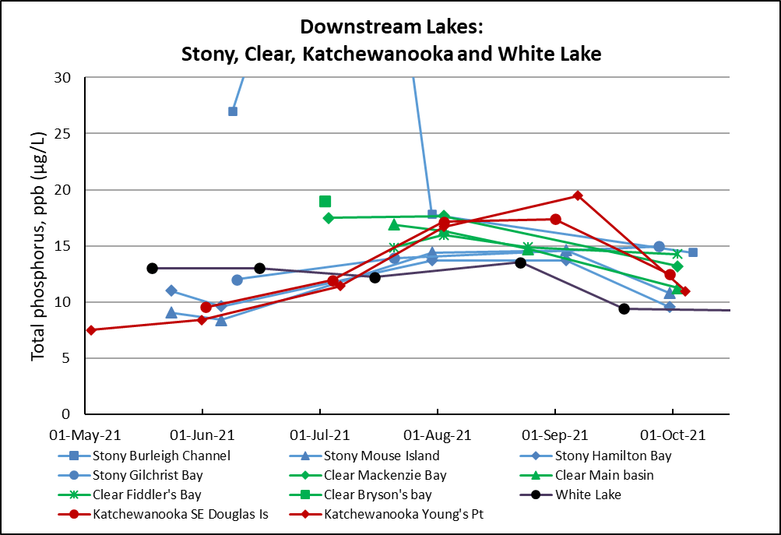
Downstream Lakes
Higher phosphorus water flowing into Stony Lake from the midstream lakes is diluted with low phosphorus water from Upper Stoney Lake resulting in moderate levels of phosphorus in Clear and Katchewanooka Lakes. In 2021 we observed generally lower mid-year TP levels than in 2019 and lower early-year readings than in most years. The exceptionally high early results for the Stony Lake Burleigh Channel site are unusual and unexplained.

Summary of 2021 TP Results
In general, TP levels were lower in 2021 than they have been for the past ten years. While rainfall and its effect on TSW flow have been suspected to play some role in this result, no clear correlation has been found. Is it possible that, due to the COVID-19 pandemic, fewer people were visiting the Kawartha Lakes and that this has resulted in reduced phosphorus loading?

Appendix F: 2021 Phosphorus, Secchi and Calcium Data

Total Phosphorus (TP) Measurements
In 2021 volunteers tested 47 sites in 17 Kawartha lakes. Results are listed below. A number of TP measurements are in bold type. These were considered outliers, and were not used to calculate the TP average.
STN | Site | Lake Name | Site Description | Date | TP1 | TP2 | Avg.TP
 | ID |  |  |  | (µg/L) | (µg/L) | (µg/L)
6902 | 2 | BALSAM LAKE | N Bay Rocky Pt. | 17-May-21 | 4.20 | 4.50 | 4.35
6902 | 2 | BALSAM LAKE | N Bay Rocky Pt. | 15-Jun-21 | 7.60 | 8.00 | 7.80
6902 | 2 | BALSAM LAKE | N Bay Rocky Pt. | 06-Jul-21 | 10.10 | 10.20 | 10.15
6902 | 2 | BALSAM LAKE | N Bay Rocky Pt. | 03-Aug-21 | 10.70 | 11.70 | 11.20
6902 | 2 | BALSAM LAKE | N Bay Rocky Pt. | 02-Sep-21 | 8.20 | 9.70 | 8.95
6902 | 2 | BALSAM LAKE | N Bay Rocky Pt. | 09-Oct-21 | 8.80 | 10.00 | 9.40
6902 | 5 | BALSAM LAKE | NE end-Lightning Pt | 27-May-21 | 12.00 | 12.00 | 12.00
6902 | 5 | BALSAM LAKE | NE end-Lightning Pt | 07-Jun-21 | 13.00 | 16.00 | 14.50
6902 | 5 | BALSAM LAKE | NE end-Lightning Pt | 29-Jul-21 | 7.20 | 7.80 | 7.50
6902 | 5 | BALSAM LAKE | NE end-Lightning Pt | 16-Aug-21 | 7.60 | 8.40 | 8.00
6902 | 5 | BALSAM LAKE | NE end-Lightning Pt | 29-Sep-21 | 5.80 | 6.10 | 5.95
6902 | 5 | BALSAM LAKE | NE end-Lightning Pt | 11-Oct-21 | 7.80 | 8.70 | 8.25
6902 | 7 | BALSAM LAKE | South B-Killarney B | 24-May-21 | 22.00 | 28.00 | 25.00
6902 | 7 | BALSAM LAKE | South B-Killarney B | 10-Jul-21 | 13.00 | 14.00 | 13.50
6902 | 7 | BALSAM LAKE | South B-Killarney B | 21-Aug-21 | 133.00 | 222.00 | -
6902 | 7 | BALSAM LAKE | South B-Killarney B | 20-Sep-21 | 9.80 | 12.10 | 10.95
6902 | 7 | BALSAM LAKE | South B-Killarney B | 27-Oct-21 | 10.70 | 12.60 | 11.65
6902 | 8 | BALSAM LAKE | W Bay2, deep spot | 01-Jun-21 | 5.60 | 5.80 | 5.70
6902 | 8 | BALSAM LAKE | W Bay2, deep spot | 02-Jul-21 | 9.80 | 11.00 | 10.40
6902 | 8 | BALSAM LAKE | W Bay2, deep spot | 30-Jul-21 | 8.70 | 9.70 | 9.20
6902 | 8 | BALSAM LAKE | W Bay2, deep spot | 07-Sep-21 | 9.20 | 10.10 | 9.65
6902 | 9 | BALSAM LAKE | E of Grand Is | 31-May-21 | 5.30 | 5.40 | 5.35
6941 | 1 | BIG BALD LAKE | Mid Lake, deep spot | 27-May-21 | 11.00 | 11.00 | 11.00
6941 | 1 | BIG BALD LAKE | Mid Lake, deep spot | 28-Jun-21 | 11.00 | 12.00 | 11.50
6941 | 1 | BIG BALD LAKE | Mid Lake, deep spot | 20-Jul-21 | 11.30 | 11.60 | 11.45
6941 | 1 | BIG BALD LAKE | Mid Lake, deep spot | 16-Aug-21 | 10.70 | 12.20 | 11.45
6941 | 1 | BIG BALD LAKE | Mid Lake, deep spot | 10-Sep-21 | 8.60 | 8.90 | 8.75
6941 | 1 | BIG BALD LAKE | Mid Lake, deep spot | 06-Oct-21 | 8.50 | 8.70 | 8.60
363 | 1 | BIG CEDAR LAKE | Mid Lake, deep spot | 24-May-21 | 6.20 | 6.70 | 6.45
7131 | 1 | BUCKHORN LAKE (U) | Narrows-redbuoy C310 | 21-Jul-21 | 15.50 | 16.20 | 15.85
7131 | 1 | BUCKHORN LAKE (U) | Narrows-redbuoy C310 | 03-Aug-21 | 15.80 | 15.90 | 15.85
7131 | 9 | BUCKHORN LAKE (U) | Young's Cove, Deep Spot | 27-May-21 | 17.00 | 18.00 | 17.50
7131 | 9 | BUCKHORN LAKE (U) | Young's Cove, Deep Spot | 14-Jun-21 | 20.00 | 23.00 | 21.50
7131 | 9 | BUCKHORN LAKE (U) | Young's Cove, Deep Spot | 25-Jul-21 | 15.40 | 24.20 | 19.80
7131 | 9 | BUCKHORN LAKE (U) | Young's Cove, Deep Spot | 22-Aug-21 | 11.40 | 12.10 | 11.75
7131 | 9 | BUCKHORN LAKE (U) | Young's Cove, Deep Spot | 19-Sep-21 | 12.90 | 13.10 | 13.00
7131 | 10 | BUCKHORN LAKE (U) | NE of Fox Is | 23-May-21 | 12.00 | 12.00 | 12.00
7131 | 10 | BUCKHORN LAKE (U) | NE of Fox Is | 19-Jun-21 | 20.00 | 26.00 | 23.00
7131 | 10 | BUCKHORN LAKE (U) | NE of Fox Is | 18-Jul-21 | 14.00 | 17.00 | 15.50
7131 | 10 | BUCKHORN LAKE (U) | NE of Fox Is | 21-Aug-21 | 10.10 | 10.20 | 10.15
7131 | 10 | BUCKHORN LAKE (U) | NE of Fox Is | 18-Sep-21 | 10.40 | 12.40 | 11.40
7131 | 10 | BUCKHORN LAKE (U) | NE of Fox Is | 15-Oct-21 | 8.00 | 8.30 | 8.15
6905 | 6 | CAMERON LAKE | S end, deep spot | 13-Jun-21 | 7.40 | 8.10 | 7.75
6905 | 6 | CAMERON LAKE | S end, deep spot | 11-Jul-21 | 11.00 | 11.00 | 11.00
6905 | 6 | CAMERON LAKE | S end, deep spot | 15-Aug-21 | 9.50 | 10.40 | 9.95
6905 | 6 | CAMERON LAKE | S end, deep spot | 19-Sep-21 | 7.40 | 7.90 | 7.65
6951 | 9 | CHEMONG LAKE | S. of Causeway | 31-May-21 | 10.00 | 11.00 | 10.50
6951 | 9 | CHEMONG LAKE | S. of Causeway | 29-Jun-21 | 16.00 | 17.00 | 16.50
6951 | 9 | CHEMONG LAKE | S. of Causeway | 28-Jul-21 | 13.10 | 22.10 | 17.60
6951 | 9 | CHEMONG LAKE | S. of Causeway | 25-Aug-21 | 348.00 | 359.00 | -
6951 | 9 | CHEMONG LAKE | S. of Causeway | 29-Sep-21 | 13.90 | 14.30 | 14.10
6951 | 11 | CHEMONG LAKE | N of Big Island | 01-Jun-21 | 7.80 | 10.00 | 8.90
6951 | 11 | CHEMONG LAKE | N of Big Island | 03-Jul-21 | 13.30 | 14.10 | 13.70
6951 | 11 | CHEMONG LAKE | N of Big Island | 02-Aug-21 | 14.40 | 15.30 | 14.85
6951 | 11 | CHEMONG LAKE | N of Big Island | 07-Sep-21 | 10.20 | 12.30 | 11.25
6955 | 1 | CLEAR LAKE | MacKenzie Bay | 04-Jul-21 | 17.00 | 18.00 | 17.50
6955 | 1 | CLEAR LAKE | MacKenzie Bay | 03-Aug-21 | 17.60 | 17.70 | 17.65
6955 | 1 | CLEAR LAKE | MacKenzie Bay | 03-Oct-21 | 12.50 | 13.90 | 13.20
6955 | 2 | CLEAR LAKE | Main Basin-deep spot | 21-Jul-21 | 16.90 | 16.90 | 16.90
6955 | 2 | CLEAR LAKE | Main Basin-deep spot | 03-Aug-21 | 16.00 | 16.70 | 16.35
6955 | 2 | CLEAR LAKE | Main Basin-deep spot | 25-Aug-21 | 14.30 | 15.10 | 14.70
6955 | 2 | CLEAR LAKE | Main Basin-deep spot | 03-Oct-21 | 10.80 | 11.70 | 11.25
6955 | 3 | CLEAR LAKE | Fiddlers Bay | 21-Jul-21 | 14.70 | 15.00 | 14.85
6955 | 3 | CLEAR LAKE | Fiddlers Bay | 03-Aug-21 | 15.60 | 16.30 | 15.95
6955 | 3 | CLEAR LAKE | Fiddlers Bay | 25-Aug-21 | 14.50 | 15.30 | 14.90
6955 | 3 | CLEAR LAKE | Fiddlers Bay | 03-Oct-21 | 14.00 | 14.50 | 14.25
6955 | 4 | CLEAR LAKE | Brysons Bay | 03-Jul-21 | 19.00 |  | 19.00
7075 | 2 | JULIAN LAKE | Mid Lake, deep spot | 31-May-21 | 4.80 | 6.00 | 5.40
7076 | 1 | KATCHEWANOOKA LAKE | S/E Douglas Island | 02-Jun-21 | 9.30 | 9.80 | 9.55
7076 | 1 | KATCHEWANOOKA LAKE | S/E Douglas Island | 05-Jul-21 | 11.90 | 12.00 | 11.95
7076 | 1 | KATCHEWANOOKA LAKE | S/E Douglas Island | 03-Aug-21 | 16.60 | 17.70 | 17.15
7076 | 1 | KATCHEWANOOKA LAKE | S/E Douglas Island | 01-Sep-21 | 17.30 | 17.50 | 17.40
7076 | 1 | KATCHEWANOOKA LAKE | S/E Douglas Island | 01-Oct-21 | 12.20 | 12.70 | 12.45
7076 | 2 | KATCHEWANOOKA LAKE | Young Pt near locks | 03-May-21 | 7.10 | 7.90 | 7.50
7076 | 2 | KATCHEWANOOKA LAKE | Young Pt near locks | 01-Jun-21 | 8.20 | 8.60 | 8.40
7076 | 2 | KATCHEWANOOKA LAKE | Young Pt near locks | 07-Jul-21 | 10.80 | 12.00 | 11.40
7076 | 2 | KATCHEWANOOKA LAKE | Young Pt near locks | 03-Aug-21 | 16.20 | 17.20 | 16.70
7076 | 2 | KATCHEWANOOKA LAKE | Young Pt near locks | 07-Sep-21 | 19.30 | 19.60 | 19.45
7076 | 2 | KATCHEWANOOKA LAKE | Young Pt near locks | 05-Oct-21 | 10.90 | 11.00 | 10.95
7087 | 1 | LOVESICK LAKE | 80' hole at N. end | 31-May-21 | 6.30 | 17.80 | 12.05
7087 | 1 | LOVESICK LAKE | 80' hole at N. end | 17-Jun-21 | 22.10 | 57.00 | 22.10
7087 | 1 | LOVESICK LAKE | 80' hole at N. end | 19-Jul-21 | 16.20 | 18.50 | 17.35
7087 | 1 | LOVESICK LAKE | 80' hole at N. end | 03-Aug-21 | 14.30 | 20.50 | 17.40
7087 | 1 | LOVESICK LAKE | 80' hole at N. end | 07-Sep-21 | 13.60 | 19.70 | 16.65
7087 | 1 | LOVESICK LAKE | 80' hole at N. end | 02-Oct-21 | 19.10 | 38.30 | 19.10
7087 | 3 | LOVESICK LAKE | McCallum Island | 31-May-21 | 7.00 | 17.00 | 12.00
7087 | 3 | LOVESICK LAKE | McCallum Island | 17-Jun-21 | 5.90 | 17.00 | 11.45
7087 | 3 | LOVESICK LAKE | McCallum Island | 19-Jul-21 | 18.20 | 23.90 | 21.05
7087 | 3 | LOVESICK LAKE | McCallum Island | 03-Aug-21 | 13.20 | 21.30 | 17.25
7087 | 3 | LOVESICK LAKE | McCallum Island | 07-Sep-21 | 13.80 | 20.90 | 17.35
7087 | 3 | LOVESICK LAKE | McCallum Island | 02-Oct-21 | 16.10 | 22.90 | 19.50
6990 | 1 | LOWER BUCKHORN LAKE | Heron Island | 02-Jun-21 | 13.00 | 14.00 | 13.50
6990 | 1 | LOWER BUCKHORN LAKE | Heron Island | 05-Jul-21 | 18.00 | 21.00 | 19.50
6990 | 1 | LOWER BUCKHORN LAKE | Heron Island | 25-Jul-21 | 16.90 | 17.10 | 17.00
6990 | 1 | LOWER BUCKHORN LAKE | Heron Island | 23-Aug-21 | 14.90 | 17.00 | 15.95
6990 | 1 | LOWER BUCKHORN LAKE | Heron Island | 06-Sep-21 | 14.90 | 15.00 | 14.95
6990 | 1 | LOWER BUCKHORN LAKE | Heron Island | 26-Sep-21 | 12.00 | 12.10 | 12.05
6990 | 4 | LOWER BUCKHORN LAKE | Deer Bay W-Buoy C267 | 27-May-21 | 13.00 | 15.00 | 14.00
6990 | 4 | LOWER BUCKHORN LAKE | Deer Bay W-Buoy C267 | 29-Jun-21 | 14.00 | 16.00 | 15.00
6990 | 4 | LOWER BUCKHORN LAKE | Deer Bay W-Buoy C267 | 21-Jul-21 | 18.30 | 19.80 | 19.05
6990 | 4 | LOWER BUCKHORN LAKE | Deer Bay W-Buoy C267 | 13-Aug-21 | 18.00 | 19.00 | 18.50
6990 | 4 | LOWER BUCKHORN LAKE | Deer Bay W-Buoy C267 | 03-Sep-21 | 15.70 | 16.30 | 16.00
6990 | 4 | LOWER BUCKHORN LAKE | Deer Bay W-Buoy C267 | 09-Oct-21 | 9.10 | 10.90 | 10.00
6990 | 6 | LOWER BUCKHORN LAKE | Deer Bay-centre | 02-Jun-21 | 11.00 | 13.00 | 12.00
6990 | 6 | LOWER BUCKHORN LAKE | Deer Bay-centre | 05-Jul-21 | 14.00 | 17.00 | 15.50
6990 | 6 | LOWER BUCKHORN LAKE | Deer Bay-centre | 25-Jul-21 | 17.90 | 19.30 | 18.60
6990 | 6 | LOWER BUCKHORN LAKE | Deer Bay-centre | 23-Aug-21 | 15.20 | 15.30 | 15.25
6990 | 6 | LOWER BUCKHORN LAKE | Deer Bay-centre | 06-Sep-21 | 21.90 | 23.40 | 22.65
6990 | 6 | LOWER BUCKHORN LAKE | Deer Bay-centre | 26-Sep-21 | 14.60 | 15.40 | 15.00
6990 | 7 | LOWER BUCKHORN LAKE | Lower Deer Bay, Mid-deep | 30-May-21 | 13.00 | 18.00 | 15.50
6990 | 7 | LOWER BUCKHORN LAKE | Lower Deer Bay, Mid-deep | 04-Jun-21 | 17.00 | 18.00 | 17.50
6990 | 7 | LOWER BUCKHORN LAKE | Lower Deer Bay, Mid-deep | 11-Jul-21 | 16.00 | 17.00 | 16.50
6990 | 7 | LOWER BUCKHORN LAKE | Lower Deer Bay, Mid-deep | 05-Aug-21 | 16.60 | 18.50 | 17.55
6990 | 7 | LOWER BUCKHORN LAKE | Lower Deer Bay, Mid-deep | 02-Sep-21 | 17.20 | 22.70 | 19.95
6990 | 7 | LOWER BUCKHORN LAKE | Lower Deer Bay, Mid-deep | 03-Oct-21 | 10.90 | 12.50 | 11.70
6990 | 8 | LOWER BUCKHORN LAKE | Main basin, deep- spot | 24-May-21 | 12.00 |  | 12.00
6990 | 8 | LOWER BUCKHORN LAKE | Main basin, deep- spot | 04-Jun-21 | 18.00 | 20.00 | 19.00
6990 | 8 | LOWER BUCKHORN LAKE | Main basin, deep- spot | 11-Jul-21 | 17.00 | 18.00 | 17.50
6990 | 8 | LOWER BUCKHORN LAKE | Main basin, deep- spot | 05-Aug-21 | 14.10 | 45.10 | 14.10
6990 | 8 | LOWER BUCKHORN LAKE | Main basin, deep- spot | 02-Sep-21 | 12.60 | 13.90 | 13.25
6990 | 8 | LOWER BUCKHORN LAKE | Main basin, deep- spot | 03-Oct-21 | 10.40 | 11.50 | 10.95
6919 | 1 | PIGEON LAKE | S end, deep spot | 13-May-21 | 22.00 | 22.00 | 22.00
6919 | 1 | PIGEON LAKE | S end, deep spot | 10-Jun-21 | 22.00 | 24.00 | 23.00
6919 | 1 | PIGEON LAKE | S end, deep spot | 15-Jul-21 | 19.00 | 19.00 | 19.00
6919 | 1 | PIGEON LAKE | S end, deep spot | 17-Aug-21 | 16.40 | 18.60 | 17.50
6919 | 1 | PIGEON LAKE | S end, deep spot | 19-Sep-21 | 15.50 | 15.60 | 15.55
6919 | 1 | PIGEON LAKE | S end, deep spot | 14-Oct-21 | 13.10 | 13.20 | 13.15
6919 | 3 | PIGEON LAKE | Middle-SandyPtBoyd I | 07-Sep-21 | 17.40 | 24.40 | 17.40
6919 | 3 | PIGEON LAKE | Middle-SandyPtBoyd I | 09-Oct-21 | 11.90 | 13.00 | 12.45
6919 | 12 | PIGEON LAKE | N-400m N of Boyd Is. | 02-Jun-21 | 7.10 | 7.90 | 7.50
6919 | 12 | PIGEON LAKE | N-400m N of Boyd Is. | 03-Jul-21 | 17.00 | 19.00 | 18.00
6919 | 12 | PIGEON LAKE | N-400m N of Boyd Is. | 05-Aug-21 | 16.30 | 18.20 | 17.25
6919 | 12 | PIGEON LAKE | N-400m N of Boyd Is. | 06-Sep-21 | 12.50 | 13.00 | 12.75
6919 | 12 | PIGEON LAKE | N-400m N of Boyd Is. | 04-Oct-21 | 12.30 | 13.00 | 12.65
6919 | 13 | PIGEON LAKE | N end-Adjacent Con17 | 02-Jul-21 | 20.00 | 37.00 | 20.00
6919 | 13 | PIGEON LAKE | N end-Adjacent Con17 | 07-Sep-21 | 16.30 | 16.90 | 16.60
6919 | 13 | PIGEON LAKE | N end-Adjacent Con17 | 09-Oct-21 | 14.80 | 17.20 | 16.00
6919 | 15 | PIGEON LAKE | C340-DeadHorseSho | 17-May-21 | 8.30 | 11.00 | 9.65
6919 | 15 | PIGEON LAKE | C340-DeadHorseSho | 04-Jun-21 | 7.10 | 7.60 | 7.35
6919 | 15 | PIGEON LAKE | C340-DeadHorseSho | 03-Jul-21 | 12.00 | 12.00 | 12.00
6919 | 15 | PIGEON LAKE | C340-DeadHorseSho | 02-Aug-21 | 16.30 | 24.50 | 16.30
6919 | 15 | PIGEON LAKE | C340-DeadHorseSho | 03-Sep-21 | 14.60 | 15.20 | 14.90
6919 | 15 | PIGEON LAKE | C340-DeadHorseSho | 05-Oct-21 | 13.50 | 13.60 | 13.55
6919 | 16 | PIGEON LAKE | N300yds off Bottom I | 02-Jun-21 | 8.50 | 8.90 | 8.70
6919 | 16 | PIGEON LAKE | N300yds off Bottom I | 03-Jul-21 | 18.00 | 18.00 | 18.00
6919 | 16 | PIGEON LAKE | N300yds off Bottom I | 05-Aug-21 | 10.30 | 20.20 | 10.30
6919 | 16 | PIGEON LAKE | N300yds off Bottom I | 06-Sep-21 | 11.40 |  | 11.40
6919 | 16 | PIGEON LAKE | N300yds off Bottom I | 04-Oct-21 | 10.90 | 12.60 | 11.75
7241 | 2 | SANDY LAKE | Mid Lake, deep spot | 30-Jun-21 | 6.40 | 6.50 | 6.45
7241 | 2 | SANDY LAKE | Mid Lake, deep spot | 21-Aug-21 | 4.40 | 5.10 | 4.75
7241 | 2 | SANDY LAKE | Mid Lake, deep spot | 10-Sep-21 | 5.30 | 5.40 | 5.35
7241 | 2 | SANDY LAKE | Mid Lake, deep spot | 26-Sep-21 | 5.70 | 6.00 | 5.85
7241 | 2 | SANDY LAKE | Mid Lake, deep spot | 11-Oct-21 | 5.80 | 7.20 | 6.50
7133 | 4 | STONY LAKE | Burleigh locks chan. | 09-Jun-21 | 27.00 | 27.00 | 27.00
7133 | 4 | STONY LAKE | Burleigh locks chan. | 13-Jul-21 | 59.00 | 67.00 | 63.00
7133 | 4 | STONY LAKE | Burleigh locks chan. | 31-Jul-21 | 17.80 | 17.80 | 17.80
7133 | 4 | STONY LAKE | Burleigh locks chan. | 07-Oct-21 | 11.50 | 17.30 | 14.40
7133 | 6 | STONY LAKE | Gilchrist Bay | 10-Jun-21 | 12.00 | 12.00 | 12.00
7133 | 6 | STONY LAKE | Gilchrist Bay | 21-Jul-21 | 13.10 | 14.70 | 13.90
7133 | 6 | STONY LAKE | Gilchrist Bay | 28-Sep-21 | 14.20 | 15.70 | 14.95
7133 | 7 | STONY LAKE | Mouse Is. | 24-May-21 | 9.00 | 9.10 | 9.05
7133 | 7 | STONY LAKE | Mouse Is. | 06-Jun-21 | 8.30 | 8.50 | 8.40
7133 | 7 | STONY LAKE | Mouse Is. | 31-Jul-21 | 14.30 | 14.50 | 14.40
7133 | 7 | STONY LAKE | Mouse Is. | 04-Sep-21 | 14.40 | 14.80 | 14.60
7133 | 7 | STONY LAKE | Mouse Is. | 01-Oct-21 | 10.60 | 11.00 | 10.80
7133 | 8 | STONY LAKE | Hamilton Bay | 24-May-21 | 11.00 | 11.00 | 11.00
7133 | 8 | STONY LAKE | Hamilton Bay | 06-Jun-21 | 9.60 | 9.60 | 9.60
7133 | 8 | STONY LAKE | Hamilton Bay | 31-Jul-21 | 13.30 | 14.10 | 13.70
7133 | 8 | STONY LAKE | Hamilton Bay | 04-Sep-21 | 13.70 | 13.70 | 13.70
7133 | 8 | STONY LAKE | Hamilton Bay | 01-Oct-21 | 9.20 | 9.90 | 9.55
6924 | 4 | STURGEON LAKE | Muskrat I-Buoy C388 | 19-Aug-21 | 13.50 | 13.50 | 13.50
6924 | 4 | STURGEON LAKE | Muskrat I-Buoy C388 | 09-Sep-21 | 16.90 | 17.50 | 17.20
6924 | 5 | STURGEON LAKE | Sturgeon Point Buoy | 17-Jun-21 | 13.00 | 13.00 | 13.00
6924 | 5 | STURGEON LAKE | Sturgeon Point Buoy | 26-Jul-21 | 13.90 | 14.00 | 13.95
6924 | 5 | STURGEON LAKE | Sturgeon Point Buoy | 27-Aug-21 | 7.10 | 14.20 | 10.65
6924 | 5 | STURGEON LAKE | Sturgeon Point Buoy | 29-Sep-21 | 11.10 | 11.60 | 11.35
6924 | 9 | STURGEON LAKE | Fenelon R. mouth | 17-Jun-21 | 11.00 | 11.00 | 11.00
6924 | 9 | STURGEON LAKE | Fenelon R. mouth | 26-Jul-21 | 11.10 | 11.20 | 11.15
6924 | 9 | STURGEON LAKE | Fenelon R. mouth | 27-Aug-21 | 6.10 | 6.10 | 6.10
6924 | 9 | STURGEON LAKE | Fenelon R. mouth | 29-Sep-21 | 7.50 | 8.00 | 7.75
5178 | 1 | UPPER STONEY LAKE | Quarry Bay | 06-Jun-21 | 5.70 | 7.00 | 6.35
5178 | 1 | UPPER STONEY LAKE | Quarry Bay | 03-Jul-21 | 9.20 | 11.00 | 10.10
5178 | 1 | UPPER STONEY LAKE | Quarry Bay | 30-Jul-21 | 7.80 | 8.10 | 7.95
5178 | 1 | UPPER STONEY LAKE | Quarry Bay | 07-Sep-21 | 7.00 | 7.70 | 7.35
5178 | 1 | UPPER STONEY LAKE | Quarry Bay | 02-Oct-21 | 13.20 | 18.10 | 13.20
5178 | 3 | UPPER STONEY LAKE | Young Bay | 06-Jun-21 | 6.60 | 7.20 | 6.90
5178 | 3 | UPPER STONEY LAKE | Young Bay | 03-Jul-21 | 7.70 | 9.60 | 8.65
5178 | 3 | UPPER STONEY LAKE | Young Bay | 30-Jul-21 | 8.10 | 9.20 | 8.65
5178 | 3 | UPPER STONEY LAKE | Young Bay | 07-Sep-21 | 6.90 | 6.90 | 6.90
5178 | 3 | UPPER STONEY LAKE | Young Bay | 02-Oct-21 | 5.70 | 7.50 | 6.60
5178 | 4 | UPPER STONEY LAKE | S Bay, deep spot | 06-Jun-21 | 9.90 | 10.00 | 9.95
5178 | 4 | UPPER STONEY LAKE | S Bay, deep spot | 03-Jul-21 | 13.00 | 18.00 | 13.00
5178 | 4 | UPPER STONEY LAKE | S Bay, deep spot | 30-Jul-21 | 8.90 | 9.90 | 9.40
5178 | 4 | UPPER STONEY LAKE | S Bay, deep spot | 07-Sep-21 | 19.50 | 19.80 | 19.65
5178 | 4 | UPPER STONEY LAKE | S Bay, deep spot | 02-Oct-21 | 5.00 | 13.50 | 5.00
5178 | 5 | UPPER STONEY LAKE | Crowes Landing | 06-Jun-21 | 6.70 | 7.60 | 7.15
5178 | 5 | UPPER STONEY LAKE | Crowes Landing | 03-Jul-21 | 7.10 | 8.40 | 7.75
5178 | 5 | UPPER STONEY LAKE | Crowes Landing | 30-Jul-21 | 8.80 | 18.30 | 8.80
5178 | 5 | UPPER STONEY LAKE | Crowes Landing | 07-Sep-21 | 7.40 | 7.80 | 7.60
5178 | 5 | UPPER STONEY LAKE | Crowes Landing | 02-Oct-21 | 8.10 | 8.10 | 8.10
5178 | 6 | UPPER STONEY LAKE | Mid Lake, deep spot | 06-Jun-21 | 6.50 | 7.00 | 6.75
5178 | 6 | UPPER STONEY LAKE | Mid Lake, deep spot | 03-Jul-21 | 23.00 | 23.00 | 23.00
5178 | 6 | UPPER STONEY LAKE | Mid Lake, deep spot | 30-Jul-21 | 9.10 | 9.10 | 9.10
5178 | 6 | UPPER STONEY LAKE | Mid Lake, deep spot | 07-Sep-21 | 7.20 | 8.50 | 7.85
5178 | 6 | UPPER STONEY LAKE | Mid Lake, deep spot | 02-Oct-21 | 6.30 | 7.40 | 6.85
6963 | 1 | WHITE LAKE (DUMMER) | S end, deep spot | 19-May-21 | 12.00 | 14.00 | 13.00
6963 | 1 | WHITE LAKE (DUMMER) | S end, deep spot | 16-Jun-21 | 13.00 | 13.00 | 13.00
6963 | 1 | WHITE LAKE (DUMMER) | S end, deep spot | 16-Jul-21 | 11.80 | 12.60 | 12.20
6963 | 1 | WHITE LAKE (DUMMER) | S end, deep spot | 23-Aug-21 | 12.40 | 14.70 | 13.55
6963 | 1 | WHITE LAKE (DUMMER) | S end, deep spot | 19-Sep-21 | 9.30 | 9.50 | 9.40
6963 | 1 | WHITE LAKE (DUMMER) | S end, deep spot | 18-Oct-21 | 9.20 | 9.30 | 9.25

2021 Secchi Depth and Calcium Measurements
Named after its inventor, Angelo Secchi, a Secchi disk is a device for measuring water clarity. It is a weighted disc 20cm in diameter with alternate black and white quadrants. When lowered into a lake, the depth at which the disc can no longer be seen (the black and white quadrants cannot be distinguished) is called the Secchi depth. The deeper the Secchi depth, the clearer the water. Basic water clarity can be affected by the amount of sediments or Dissolved Organic Matter (DOM) that the water contains. Seasonal variation of water clarity is usually related to the amount of algae it contains resulting in spring and fall Secchi Depths being greater than mid-summer values. The Lake Partner Program (LPP) asks volunteers to measure the Secchi Depth every two weeks between early May to early October. Since 2018, LPP have averaged the Secchi Depths and only provide the seasonal average which is presented here.
Calcium is a nutrient that is required by all living organisms. Aquatic species from zooplankton to crayfish depend on extracting calcium from lake water in order to grow. Levels of calcium below 2.5 mg/L can threaten the survival of many aquatic species. Calcium in lake water is derived from mineral weathering of rocks and atmospheric deposition of calcium-rich dust. Many Ontario lakes on the Precambrian Shield have been found to have very low calcium levels believed to be due to the low rate of weathering of hard, low calcium content rocks and the removal of calcium from the watershed by forest harvesting. As a result, since 2008 the Lake Partner Program (LPP) has been measuring the calcium concentration of some lake water samples for all lakes tested for Total Phosphorus. The average Calcium measurement for each site in 2021 is provided in the table below. As shown in the table, the Kawartha Lakes do not have a calcium deficiency. The limestone bedrock and calcareous soils to the south of the lakes provide more than enough calcium to sustain the aquatic life in our lakes.
STN | Site ID | Lake | Site Description | Date | Secchi Depth (m) | Calcium  (mg/L)
6902 | 2 | BALSAM LAKE | N Bay Rocky Pt. | 2021 Avg. | 5.9 | 21.4
6902 | 5 | BALSAM LAKE | NE end-Lightning Pt | 2021 Avg. | 3.9 | 17.1
6902 | 7 | BALSAM LAKE | South B-Killarney B | 2021 Avg. | 4.4 | 21.1
6902 | 8 | BALSAM LAKE | W Bay2, deep spot | 2021 Avg. |  | 21.7
6902 | 9 | BALSAM LAKE | E of Grand Is | 2021 Avg. | 5.1 | 21.5
6941 | 1 | BIG BALD LAKE | Mid Lake, deep spot | 2021 Avg. | 3.5 | 36.9
363 | 1 | BIG CEDAR LAKE | Mid Lake, deep spot | 2021 Avg. | 5.7 | 25.8
7131 | 1 | BUCKHORN LAKE (U) | Narrows-redbuoy C310 | 2021 Avg. |  | 33.6
7131 | 9 | BUCKHORN LAKE (U) | Young's Cove, deep spot | 2021 Avg. |  | 34.6
7131 | 10 | BUCKHORN LAKE (U) | NE of Fox Is | 2021 Avg. | 3.3 | 26.8
6905 | 6 | CAMERON LAKE | S end, deep spot | 2021 Avg. |  | 20.8
6951 | 9 | CHEMONG LAKE | S. of Causeway | 2021 Avg. |  | 44.6
6951 | 11 | CHEMONG LAKE | N of Big Island  Bridgenorth | 2021 Avg. |  | 50.8
6955 | 1 | CLEAR LAKE | MacKenzie Bay | 2021 Avg. |  | 30.0
6955 | 2 | CLEAR LAKE | Main Basin-deep Spot | 2021 Avg. |  | 30.9
6955 | 3 | CLEAR LAKE | Fiddlers Bay | 2021 Avg. |  | 32.5
7075 | 2 | JULIAN LAKE | Mid Lake, deep spot | 2021 Avg. |  | 42.0
7076 | 1 | KATCHEWANOOKA | S/E Douglas Island | 2021 Avg. |  | 32.3
7076 | 2 | KATCHEWANOOKA | Young Pt near locks | 2021 Avg. | 5.4 | 31.5
7087 | 1 | LOVESICK LAKE | 80' hole at N. end | 2021 Avg. |  | 34.1
7087 | 3 | LOVESICK LAKE | McCallum Island | 2021 Avg. |  | 32.7
6990 | 1 | LOWER BUCKHORN | Heron Island | 2021 Avg. |  | 33.0
6990 | 4 | LOWER BUCKHORN | Deer Bay W-Buoy C267 | 2021 Avg. |  | 32.0
6990 | 6 | LOWER BUCKHORN | Deer Bay-centre | 2021 Avg. |  | 32.6
6990 | 7 | LOWER BUCKHORN | Lower Deer Bay, Mid-deep | 2021 Avg. | 1.9 | 30.8
6990 | 8 | LOWER BUCKHORN | Main basin, deep-spot | 2021 Avg. | 2.6 | 27.8
6919 | 1 | PIGEON LAKE | S end, deep spot | 2021 Avg. | 2.6 | 30.5
6919 | 3 | PIGEON LAKE | Middle-SandyPtBoyd Is | 2021 Avg. | 3.1
6919 | 12 | PIGEON LAKE | N-400m N of Boyd Is | 2021 Avg. |  | 36.4
6919 | 13 | PIGEON LAKE | N end-Adjacent Con17 | 2021 Avg. | 3.8
6919 | 15 | PIGEON LAKE | C340-Dead Horse Shoal | 2021 Avg. | 3.0 | 37.2
6919 | 16 | PIGEON LAKE | N300yds off Bottom Is | 2021 Avg. |  | 36.8
7241 | 2 | SANDY LAKE | Main basin, deep-spot | 2021 Avg. | 4.6 | 39.0
7133 | 4 | STONY LAKE | Burleigh locks channel | 2021 Avg. |  | 31.1
7133 | 6 | STONY LAKE | Gilchrist Bay | 2021 Avg. |  | 30.0
7133 | 7 | STONY LAKE | Mouse Is. | 2021 Avg. | 4.4 | 29.6
7133 | 8 | STONY LAKE | Hamilton Bay | 2021 Avg. | 4.0 | 27.4
6924 | 5 | STURGEON LAKE | Sturgeon Point Buoy | 2021 Avg. | 2.9 | 29.8
6924 | 9 | STURGEON LAKE | Fenelon R. mouth | 2021 Avg. | 3.1 | 21.7
5178 | 1 | UPPER STONEY LAKE | Quarry Bay | 2021 Avg. |  | 27.5
5178 | 3 | UPPER STONEY LAKE | Young Bay | 2021 Avg. |  | 26.6
5178 | 4 | UPPER STONEY LAKE | S Bay, deep spot | 2021 Avg. |  | 24.6
5178 | 5 | UPPER STONEY LAKE | Crowes Landing | 2021 Avg. |  | 27.8
5178 | 6 | UPPER STONEY LAKE | Mid Lake, deep spot | 2021 Avg. |  | 27.1
6963 | 1 | WHITE LAKE (DUMMER) | S end, deep spot | 2021 Avg. | 4.8 | 31.8

